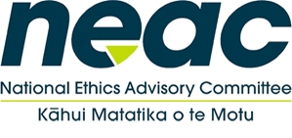
Public Meeting – National Ethical Standards for Health Research

- Introduction and welcomes 10:00am – 10:30am
- Overview of the Standards / current data from consultation 10:30am – 11:15am
- Open feedback 11:15am-12:30pm
Topic 1: Fit For Purpose
Topic 2: Scope of the Document
Topic 3: Merging the Guidelines
- Break 12:30pm-1:30pm
- Round table group discussions – case study chapter groupings 1:30pm-2:45pm
  - Research With Maori, Pacific Peoples And Participants
  - Informed Consent
  - Benefits And Harms, Research Conduct
  - Research Development, Design, Types Of Studies and Compensation
  - Data / Tissue / Biobanking

- Summary – feedback from groups 2:45 – 3:45pm
- Final thoughts 3:45pm-4:15pm

